Layers of the Atmosphere

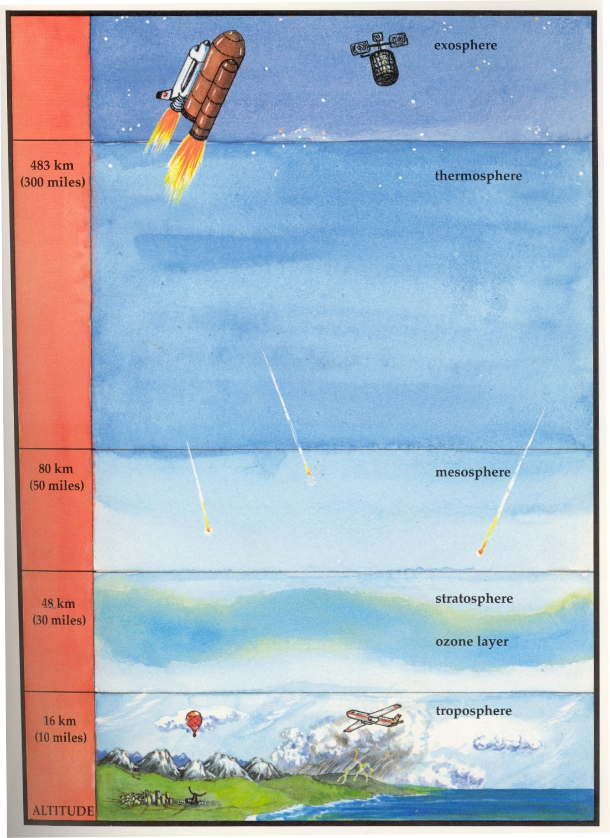

Source: The Air I Breathe, by Bobbie Kalman and Janine Schaub, Crabtree Publishing Company, 1993.